

Module: Human Computer Interaction CSC8022

Word count: 2103

MSc Computer Science

Name: Ruipeng Jiao

**REPORT**

**INTRODUCTION TO HCI AND USER EVALUATION**

**Introduction**

HCI is the process of exchanging information between a person and a computer using some kind of conversational language in a certain interactive way to accomplish a certain task or task. HCI is a discipline that studies the interaction between systems and users. The systems referred to here can be a wide variety of machines, as well as computer systems and software. The user communicates with the machine or system through a human-computer interaction interface and thus operates it.

**Principles and methods**

Donald Norman has identified seven principles for the design of human-computer interaction(Savage, R., Stader, S., McNeese, P. L., & Mouloua, M, 2005) These human-computer interaction principles will play an important role in designing systems. For practitioners, it is more about understanding the needs of the user so that more excellence can be produced in the product. More practitioners are concerned with the impact of morality, ethics and privacy on users. Many practitioners use methods such as Observation, Interview & Focus groups and Analysis of Interview Data to understand and analyse the needs of users to produce products that are more acceptable to the majority of people. (DiSalvo, 2014)

**Importance of HCI**

HCI technology is widely used and is increasingly important to computer technological innovation and other disciplines. In the past, it was often the case that developers were so focused on writing code that they forgot to consider the user experience and the visual design of the product. This can cause frustration for the user and the second layer of stress for the developer because it takes more time and resources to solve the problem. To address these issues, HCI is particularly important. In terms of technological innovation, it is not just the computer science discipline that is needed, for example, human feature extraction algorithms, fingerprint recognition technology, brainwave human-machine interface technology for people with speech and mobility impairments, etc. All of these require theoretical and technical support from a wider range of disciplines to make them accessible to a wider audience. HCI is therefore important not only for computer science but also for other disciplines.

**The different of HCI**

In the computer field, most of the things studied are related to coding, such as how to transfer information or, to a greater extent, compress files. But HCI differs from the field of computing in that it studies the way machines communicate with complex people, and this leads to HCI is a topic that needs to be studied in a multidisciplinary way. Some of the issues may involve the disciplines of perception, cognition, linguistics, and engineering.

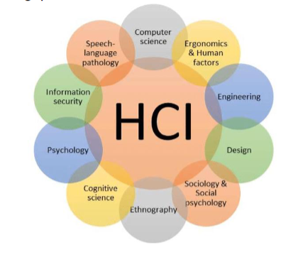

Figure 1 Multidisciplinary expertise

**Historical development of HCI**

In The Extensions of Man, published in 1964, McLuhan discussed many of the concerns and issues that would arise in the development of HCI. He influenced the development of technology and the way we respond to its understanding. One of his key concepts was that 'the medium is the message'. Twenty years later, a book by Sherry Turkle entitled: The Second Self: Computers and the Human Spirit, which explores her ethnographic research among all computer owners, discusses the issue of HCI. She moved her research from the computer to the individual level. (Petrick, 2020)

**Methodology And Findings**

Assessment is important in HCI. The focus of HCI is to help people understand how they can interact with computers, and then design and build technologies and tools that facilitate that interaction. (Wulff, & Mahling, D. E., 1990) In both theory and practice, many situations are evaluated based on the technology or the user. So that the usability of a particular product can be judged by observation, reflection and evaluation. This saves the developer or researcher a lot of time and resources to think about improving the user experience and the quality of the product itself.

**Application introduction**

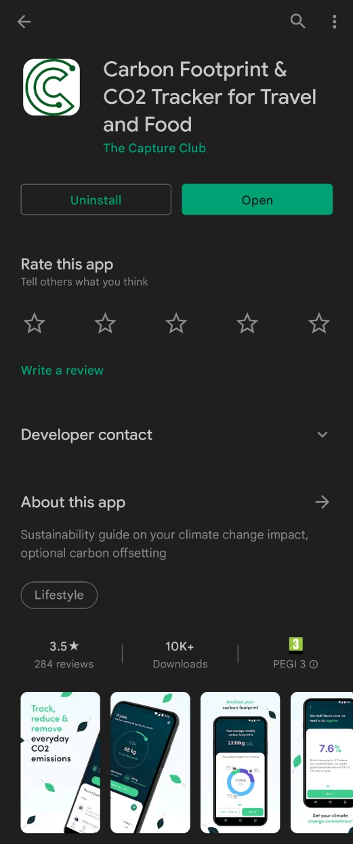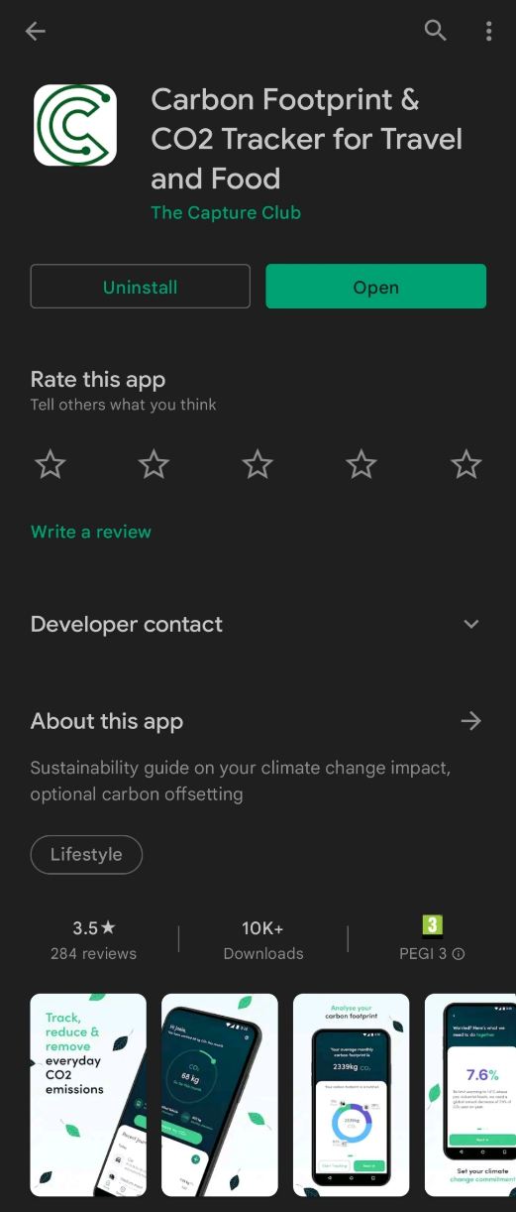The application I chose to evaluate for sustainability is called "Carbon Footprint & CO2 Tracker for Travel and Food". This is an application that calculates a person's CO2 emissions by tracking their travel patterns and food consumption over a month, thus demonstrating the impact of their carbon emissions on global climate change and thus acting as a sustainability guide. I first compared the features and design of the application horizontally. After this, the usage and functional experience of each app was compared. I felt that the 'Carbon Footprint' application had some features and experiences that were worth discussing in comparison to the other mobile applications. This is why I used it as the subject of my evaluation study.

**Assessment methods**

To evaluate the application more systematically, I decided to use the Heuristic Evaluation method to evaluate the application. Heuristic Evaluation is a method coined by Jakob Nielsen and his colleagues to identify usability problems in design. (Fuller, 1995) The concept was also pioneered in the 1993 book Usability Engineering. The basic idea behind Heuristic Evaluation is "independent evaluation followed by collaborative research".

The heuristics are first provided to the group members and each member works independently on a different task before sharing in groups. Since different evaluators will find different problems, the results of the discussion become more tangible in terms of the usability of a product. The number of Usability Problems and Evaluators should not be too high, otherwise, it will make the evaluation too difficult or fail.

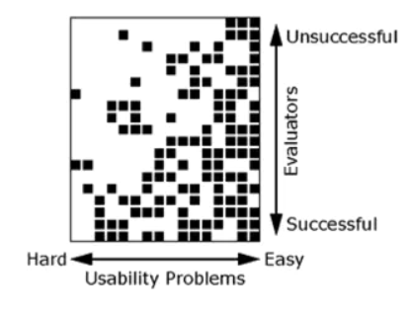

Figure 2 Assessing the impact of factors

As can be seen from Figure 3, from a cost-effectiveness point of view, 3-5 assessors are generally the best combination.

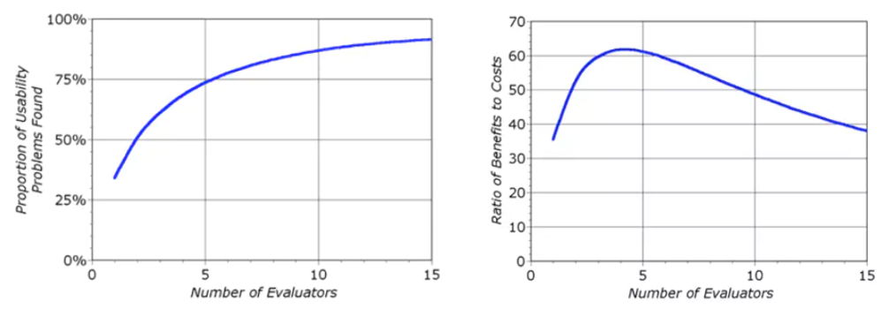

Figure 3 Optimal number of assessors

Therefore, I formed a team of 4 people with 3 other people. The application was evaluated according to the optimal number of people recommended by Jakob Nielsen.

**Heuristic assessment**

As experts familiar with the specific design and Heuristic Evaluation were able to provide specific solutions to some of the issues raised during the evaluation of the product. The feedback received is often consistently organised and structured. Heuristic Evaluation is a way to collect design feedback in a short time and at a low cost, and for products and services that are experiencing negative customer feedback, it is useful to obtain a standardised set of feedback from Heuristic Evaluation for product development. Therefore, Heuristic Evaluation is a way to understand the usability of an application.

|  |  |
| --- | --- |
| Scenario 1.  A postgraduate student at Newcastle University wanted to find out how much carbon he was emitting each day so that he could study his personal impact on environmental sustainability. So he downloaded the Carbon Footprint mobile application in order to know how much carbon he was emitting. | A.1) Login to the application |
| A.2) Get location information |
| A.3) Obtain movement data |
| A.4) Fill in the questionnaire |
| A.5) Go to the home page of the application, at this time you can view the carbon emission level |
| Scenario 2  A Newcastle University student who wants to lose weight has a busy day and checks his phone application in bed after dinner in the evening. This person wants to plan his or her travel for the next day by recording the time he or she spent walking and taking transport for the day. | B.1) Click on Record Emission on the main page |
| B.2) selects today's mode of travel |
| B.3) Select the date and duration |
| B.4) Add the size of the vehicle used for transport |
| B.5) Add the fuel type of the vehicle |
| B.6) Click on Save Record |
| Scenario 3  A socially active Newcastle University student finds out that Carbon Footprint has a community board and wants to join the community to connect with others and learn how others are using the software. | C.1) Click on the Community module |
| C.2) Search for a community name or choose to join an existing community |
| C.3) Enter Invite Code and click Join |

Four students in the group scored Jakob's Ten Usability Heuristics using the heuristic assessment method. We can collate the data as shown in Figure 4.

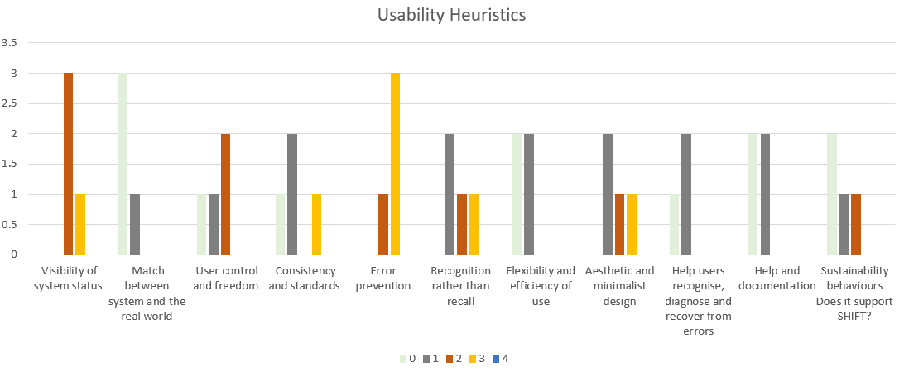

Figure 4 Usability Heuristics

The horizontal coordinate is Usability Heuristics and the vertical coordinate is the number of people who chose the number corresponding to the rating (distinguished by different colours, the brighter the colour the more serious the problem). According to this bar chart can be roughly divided into positive and negative findings.

**Positive findings**

1. Match between the system and the real world

·Interaction animation is natural and matches subconscious behaviour.

·All information is clear and there are no barriers to understanding

2. Consistency and standards

·Very introductory, rarely makes the user think of different expressions

3. Recognition rather than recall

·The logo of the button or other guidance design makes it easy for the user to find what they are looking for

4. Flexibility and efficiency of use

·No lag throughout the application

5. Aesthetic and minimalist design

·The whole application looks clean and simple

6. Help users recognize diagnose

·Error messages are written in plain English and not in code terms.

7. Help and documentation

·The application manual is almost invisible to the user.

**Negative findings**

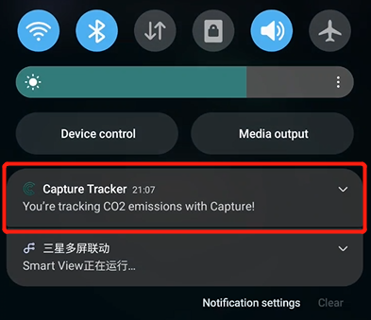1. Visibility of system status

**Issue: (1.1):** When running the application, the notification bar indicates that it is logging, but the notification remains after exiting the application and cannot be removed. This has not been tested on Apple phones, and only appears on Android phones that have agreed to the application collecting health data.

**Severity:** 2

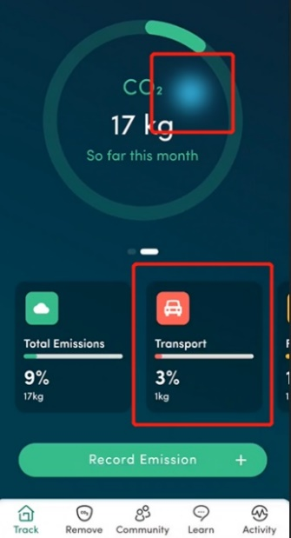**Recommendation:** Optimize notification alerts on Android phones to not pop up this message when not running an application.

**Issue: (1.2): In the UI screen of the main interface, there is a click interaction for the top circular module, but no interaction for the bottom carbon emissions panel click.**

**Severity: 1**

**Recommendation: Suggest adding click interactions so that users can view information such as carbon emission dates.**

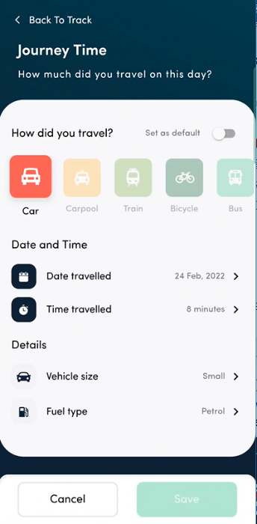

**2. Error prevention**

**Issue: (2.1): When logging into the account, the** application **requested permission to use the phone's sports health. However, the data is still not updated after normal activity through wearing the smartwatch and the phone. It can only be calculated by manually entering the mode of travel.**

**Severity: 3**

**Recommendation: Remove the requested permission or add the ability to import external data.**

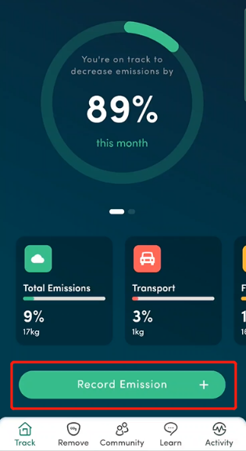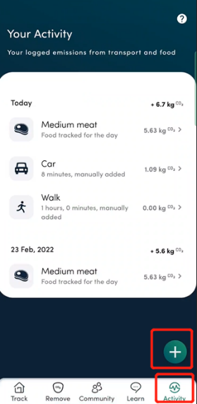**Issue:(2.2):** add duplicate travel mode function, not only on the home page but also in the Activity module

**Severity: 1**

**Recommendation: Keep the home page add method and remove the Activity module.**

**3. User control and freedom**

**Issue: (3.1): The only way to add carbon emissions is by travelling, not by food. The way in which food is added to carbon emissions should be filled out in the questionnaire and a fixed value should be added each day.**

**Severity: 3**

**Recommendation: Allow users to enter their own values for food, as this may lead to calculation errors.**

**Conclusion**

In general, an application can be analysed very quickly employing heuristic evaluation. However, adjustments need to be made to the choice and number of investigators. And as far as possible, it is important to ensure that the evaluators have some technical skills or are experts in the field. On the other hand, after the heuristic evaluation of this application, I think that the UI design is very good, but I need to reflect on whether the functionality is perfect, otherwise, problems will gradually be found in the subsequent use of the application by users, which will lead to a bad experience for them.

Four people worked on three scenarios and a dozen tasks. For the application, the Heuristic Evaluation method revealed many strengths, but still some functionality issues. For the evaluation method, Heuristic Evaluation has advantages but also limitations. Heuristic Evaluation is faster than other evaluation methods, and an experienced evaluator can complete an evaluation in just one or two hours. Not only that but Heuristic Evaluation is structured in such a way that it can explain procedural issues in advance. Because the evaluator presents the problem that needs to be solved directly to the developer, it eliminates the need to extrapolate problems and solutions from usability testing.

However, Heuristic Evaluation also has the disadvantage that an evaluator reviewing an application once can lead to false positives that are unlikely to occur in reality.

In summary, alternating the methods used to evaluate an application will greatly improve the accuracy and efficiency of the evaluation. By alternating between evaluation methods, problems can be identified at the early design stage, thus avoiding a drain on development resources and the mental energy of users. In subsequent studies, attempts will be made to use a variety of methods to evaluate products and to compare the advantages and disadvantages between the different methods, so that a suitable evaluation method can be quickly selected for future product evaluations.

**References**

Bevan. (2001). International standards for HCI and usability. *International Journal of Human-Computer Studies*, *55*(4), 533–552. <https://doi.org/10.1006/ijhc.2001.0483>

DiSalvo. (2014). The need for design history in HCI. *Interactions (New York, N.Y.)*, *21*(6), 20–21. <https://doi.org/10.1145/2669617>

Fuller. (1995). Book Review: Usability Engineering by Jakob Nielsen [Review of *Book Review: Usability Engineering by Jakob Nielsen*]. *ACM SIGCHI Bulletin*, *27*(4), 77–78. <https://doi.org/10.1145/214132.570138>

Petrick. (2020). A Historiography of Human-Computer Interaction. *IEEE Annals of the History of Computing*, *42*(4), 8–23. <https://doi.org/10.1109/MAHC.2020.3009080>

Savage, Stader, S., McNeese, P. L., & Mouloua, M. (2005). A Short History of HCI Research and Trends Published in the Journal Human Factors from 1984 to 2004. *Proceedings of the Human Factors and Ergonomics Society Annual Meeting*, *49*(7), 778–782. <https://doi.org/10.1177/154193120504900708>

Shibuya, Hamm, A., & Cerratto Pargman, T. (2022). Mapping HCI research methods for studying social media interaction: A systematic literature review. *Computers in Human Behavior*, *129*(107131), 107131. <https://doi.org/10.1016/j.chb.2021.107131>

Tenner. (2015). The Design of Everyday Things by Donald Norman (review). *Technology and Culture*, *56*(3), 785–787. <https://doi.org/10.1353/tech.2015.0104>

Wulff, & Mahling, D. E. (1990). An assessment of HCI: issues and implications. *SIGCHI Bulletin*, *22*(1), 80–87. <https://doi.org/10.1145/101288.101305>